Client output :

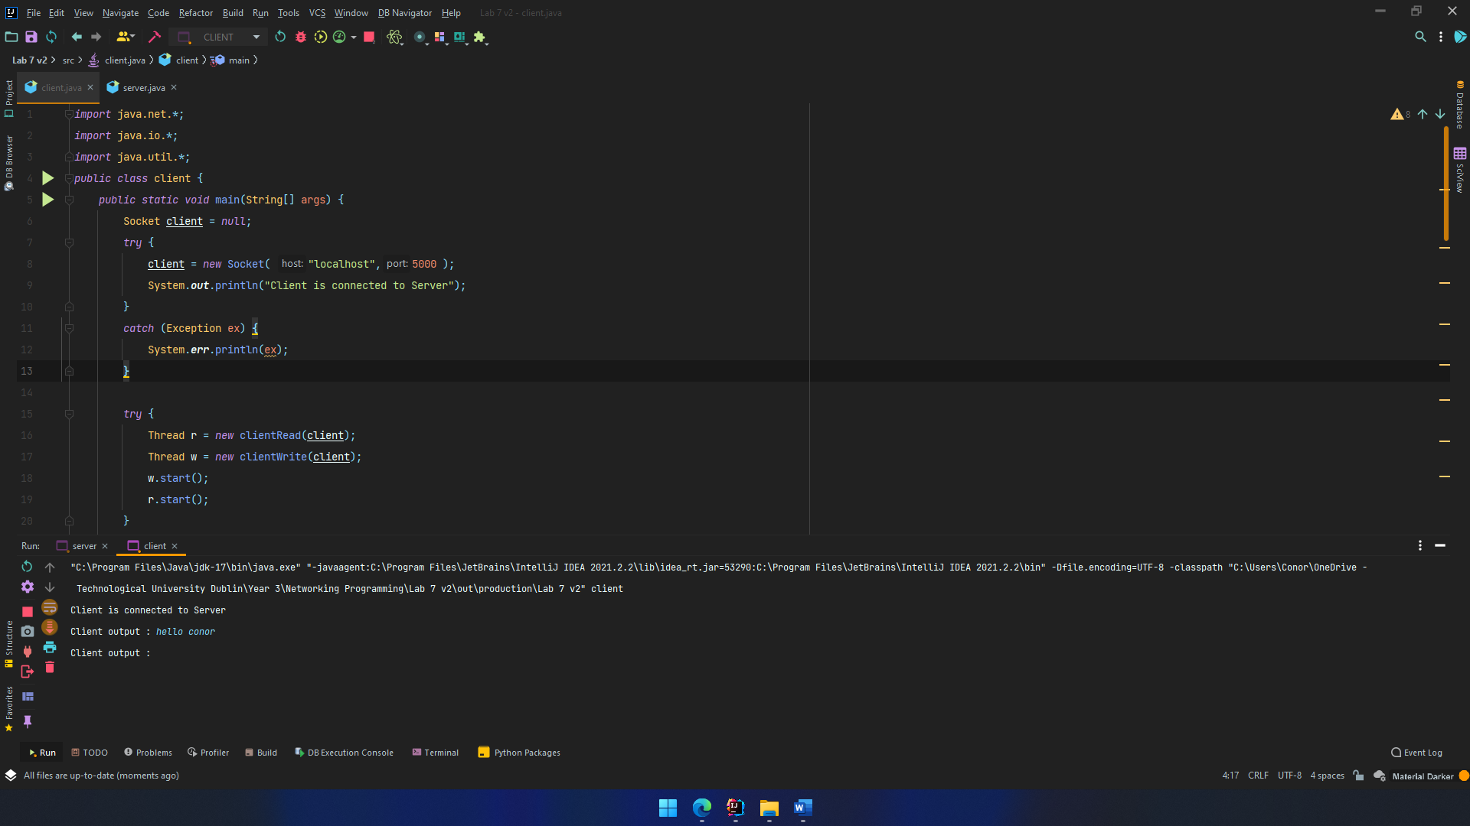

Server output :

Server source code :

*import* java.net.*;  
*import* java.io.*;  
*import* java.util.*;  
*public class* server {  
 *public static void* main(String[] args) {  
 ServerSocket server = *null*;  
 *try* {  
 server = *new* ServerSocket( 5000, 10 ); *// create ServerSocket* System.***out***.println("Server is Running on port 5000");  
 }  
 *catch* (Exception ex) {  
 System.***err***.println(ex);  
 }  
 *try* {  
 System.***out***.println("Waiting for Client to Connect");  
 Socket client = server.accept();  
 Thread r = *new* serverRead(client);  
 Thread w = *new* serverWrite(client);  
 w.start();  
 r.start();  
 }  
 *catch* (Exception ex) {  
 System.***err***.println(ex);  
 }  
 }  
}  
  
*class* serverRead *extends* Thread {  
 *private* Socket connection;  
 *public* serverRead(Socket con){  
 connection = con;  
 }  
 *public void* run() {  
 *try* {  
 ObjectInputStream in = *new* ObjectInputStream( connection.getInputStream() );  
 String message;  
 *while* (*true*){  
 message = ( String ) in.readObject();  
 System.***out***.println ("Server reads : " + message);  
 }  
  
 }  
 *catch* (Exception ex) {  
 System.***err***.println(ex);  
 }  
 }  
}  
  
*class* serverWrite *extends* Thread {  
  
 *private* Socket connection;  
 *public* serverWrite(Socket con){  
 connection = con;  
 }  
 *public void* run() {  
 *try* {  
 ObjectOutputStream out = *new* ObjectOutputStream( connection.getOutputStream() );  
 String message;  
 Scanner s = *new* Scanner(System.***in***);  
 *while* (*true*){  
 System.***out***.print("Server output : ");  
 message = s.nextLine();  
 out.writeObject(message);  
 }  
 }  
 *catch* (Exception ex) {  
 System.***err***.println(ex);  
 }  
 }  
}

Client source code :

*import* java.net.*;  
*import* java.io.*;  
*import* java.util.*;  
*public class* client {  
 *public static void* main(String[] args) {  
 Socket client = *null*;  
 *try* {  
 client = *new* Socket( "localhost",5000 );  
 System.***out***.println("Client is connected to Server");  
 }  
 *catch* (Exception ex) {  
 System.***err***.println(ex);  
 }  
  
 *try* {  
 Thread r = *new* clientRead(client);  
 Thread w = *new* clientWrite(client);  
 w.start();  
 r.start();  
 }  
 *catch* (Exception ex) {  
 System.***err***.println(ex);  
 }  
 }  
}  
  
*class* clientRead *extends* Thread {  
 *private* Socket connection;  
 *public* clientRead(Socket con){  
 connection = con;  
 }  
 *public void* run() {  
 *try* {  
  
 ObjectInputStream in = *new* ObjectInputStream( connection.getInputStream() );  
 String message;  
 *while* (*true*){  
 message = ( String ) in.readObject();  
 System.***out***.println ("Client reads : " + message);  
 }  
  
 }  
 *catch* (Exception ex) {  
 System.***err***.println(ex);  
 }  
 }  
}  
  
*class* clientWrite *extends* Thread {  
 *private* Socket connection;  
 *public* clientWrite(Socket con){  
 connection = con;  
 }  
 *public void* run() {  
 *try* {  
 ObjectOutputStream out = *new* ObjectOutputStream( connection.getOutputStream() );  
 String message;  
 Scanner s = *new* Scanner(System.***in***);  
 *while* (*true*){  
 System.***out***.print("Client output : ");  
 message = s.nextLine();  
 out.writeObject(message);  
 } }  
 *catch* (Exception ex) {  
 System.***err***.println(ex);  
 }  
 }  
}